Hours Calculation

Step 1: Open the excel book to calculate hours from schedule

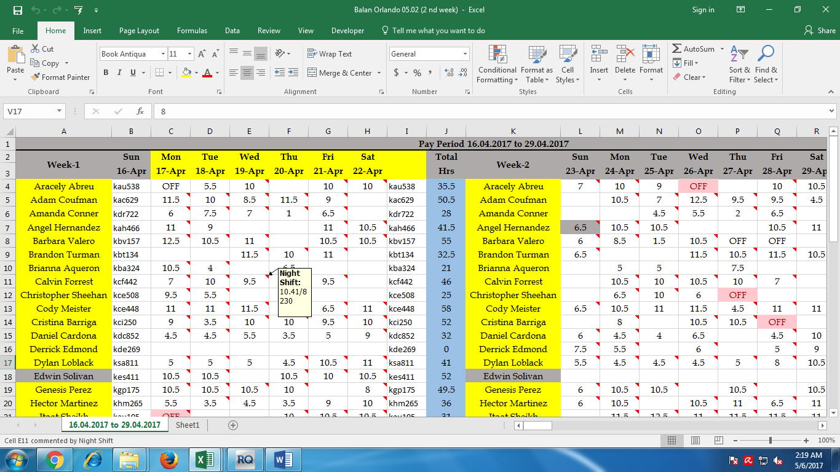

Note Make sure the book has two sheets

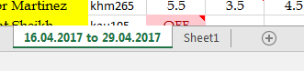

Step 2: Copy the schedule from mail and paste special in sheet1 then click on appropriate function to change column and set the date and run the macro

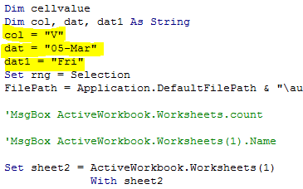

Step 3 : Open Payroll hours workbook to update the hours

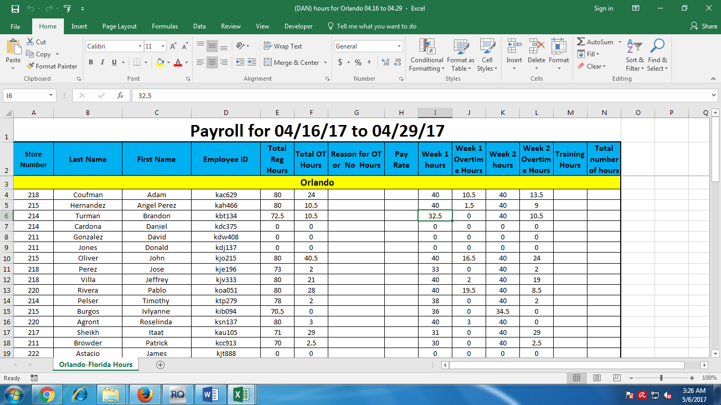

Note Make sure All rows In I,J,K,L are empty

Step 4: Focus to hours workbook then run the macro from it.